Summary of Meeting 1 of the ECAL Laser Task Force,
April 18, 2011 18:00 (Geneva Time)

Connected: Ren-Yuan Zhu, Marc Dejardin, Roger Russack (part time)
Wolfram Zeuner

Basis of the discussion – a) Mandate of the Task Force by Tommaso
b) Detector Note by Marc – Knowns and unknowns about the ECAL laser monitoring system
c) Talk at the ECAL Plenary on Dec. 7 2010 by Ren-Yuan

First point of discussion was the need of a second optical switch.
There was agreement that the second optical switch that is currently available is not suited as spare for the one in use, because it does not have enough outputs.
To add a smaller switch at the input to gain a few more output channels is not recommended, as in case of an emergency the switch should be quickly changeable. Although up to now there are no signs of ageing or failing, the need of this spare was emphasized because of the crucial importance of this switch for the operation of the whole laser system.
The selection of the switch dates back to 1996, but it is still available. However, Roger pointed out that a market survey should be carried out again to check whether or not better (or more cost effective) alternatives exist. Ren-Yuan agreed to do so.

Second point of discussion was the future of the blue laser (440nm) system for the ECAL Barrel.
The system has two problems – a) The production of the Quantronix YLF (527DQ) pumping laser has been stopped.
b) The system shows some not fully understood instabilities, which can affect the performance in measuring the transparency of the crystals.
The system has the feature to be able to provide high-energy laser pulses (>1mJ) to simulate the crystal response to up to 1.3TeV photons.

The first conclusion, which was reached, is that the current system must be maintained until the first long shutdown of LHC. Though the production of the pump-laser has been discontinued since 2005, spare parts can still be bought. It is important that enough spare parts are procured, even for the case that the shutdown will be delayed into spring or summer 2013, as currently discussed.

It followed a long discussion on the future of the blue laser system. Particularly Roger pointed out that any change of the system to replace the pumping laser should be used to also to address the instabilities. He asked to “think big” and consider also major changes of the entire system. He also questioned whether the possibility to create very high-energy pulses is necessary and whether this feature might compromise the reliability of the system.
W.Z. remarked that major re-design would require a test system with the 37th SM, which does not exist. Building it would require significant additional resources. Marc grounded the discussion by mentioning that the major instabilities are result of shutting down the system and restarting it. The vast majority of power cycles are caused by maintenance and repair interventions, particularly on the pumping laser. Ren-Yuan pointed out that the solution proposed in his talk in December exactly addresses this problem.
For the YLF pumping laser there is a similar successor model, which is pumped by laser diodes instead of a Kr-lamp. Experience from other users supports the expectation that this instrument will run for years without major interventions.
Also the trimming of the new model has a finer granularity.
Marc agreed with Ren-Yuan’s argument and pointed out that however, parts of the problems are caused by the photo-detectors, which will stay.

To answer the question of Roger concerning the necessary energy range of the laser pulse Ren-Yuan was asked to remind us of the main parameters of the system. The list is appended at the bottom together with a plot showing that the energy of the Ti:Sapphire pulse and the width are strongly correlated, as can be seen in the plot from Ren-Yuan.

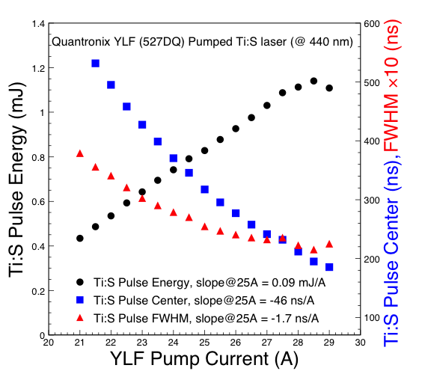

Asking for a much lower energy pulse would require also changing the Ti:Sapphire laser.
This would have a serious impact on the cost of the project.

At this point the discussion was stopped.
In the next meeting I would like to discuss once more the parameter space of the system. From Ren-Yuan I would like to learn what are the prospects of the Ti:Sapphire laser on the long term.
From Brad I would like to get an idea on the financial constraints and considerations.

Laser Specs from Ren-Yuan
The original ECAL monitoring laser specifications were defined in the ECAL TDR, which fit the laser technology available then. They are

1) Two Wavelengths: one close to the emission peak which provides the best monitoring linearity for the PWO crystals, and the other provides cross checks.
2) Spectral Contamination: < 10^-3.
3) Pulse Width: full width at half maximum (FWHM) < 40 ns to match the ECAL readout.
4) Pulse Jitters: < 3 ns for trigger synchronization to the LHC beam.
5) Pulse Repetition Rate: 100 Hz, which is the rate at which the ’spy mode’ ECAL DAQ used for monitoring events can operate.
6) Pulse Energy: > 1 mJ/pulse at monitoring wavelength, corresponding to 1.3 TeV in full dynamic range, and a linear attenuator at 1% step down to 13 GeV.
7) Pulse Intensity Instability: < 10% to guarantee monitoring precision of 0.1% by using a Si photo-diode normalization.

After more then a decade running, we modified a few items in our 2010 RFQ. They are

3) Pulse Width: full width at half maximum (FWHM) < 25 ns, which has been used during LHC runs.
5) Pulse Repetition Rate: 0 to 100 Hz, which is important since our lasers are running at a reactive mode with long waiting time some times.
7) Pulse Intensity Instability: < 3%, which can now be achieved with diode pumping.
8) Pulse delay from external trigger: < 89 us, which is important to have laser monitoring done in one LHC cycle.

We did not change the laser pulse energy requirement of > 1 mJ since it is also constrained by the pulse width requirement. Attached, please find a PDF file showing the average laser pulse energy, width and timing as a function of pumping current for our laser system including both YLF and Ti:S lasers. As you can see that a pulse width of 25 ns can be achieved when the DC Kr lamp pumped Nd:YLF lasers run at 25A to 26 A. The corresponding laser pulse energy is 0.4 to 0.5 mJ. This relation between laser pulse energy and width is an intrinsic feature of our Ti:Sapphire laser. A narrower pulse would need a higher pulse intensity. Since what we proposed was a upgrade for the pump laser not the entire laser system we should keep 1 mJ/pulse to preserve < 25 ns pulse width.

This constraint, however, would not apply if we also upgrade our Ti:Sapphire lasers. If so, the system cost would be significantly high.

==============================================================

W.Z. – CERN, April, 21

