**In case of power cut, restart laser remotely**

***Following power glitch 1st June 2025***

summary of night 1st June:

* Manage to get the VNC only once, for ecal-laser-room-02 and start the script ./laser Else ecal can not start global run. Rebooting the PC didn’t help.
* Need to go to laser lab to ARM safety system 🡺 **ICS box, press “ARM” button”**

**After:**

* Blue and green laser ON/OFF procedure

1. **VME crate:**

In case: Remote control via CMSonline , under Crate Details:

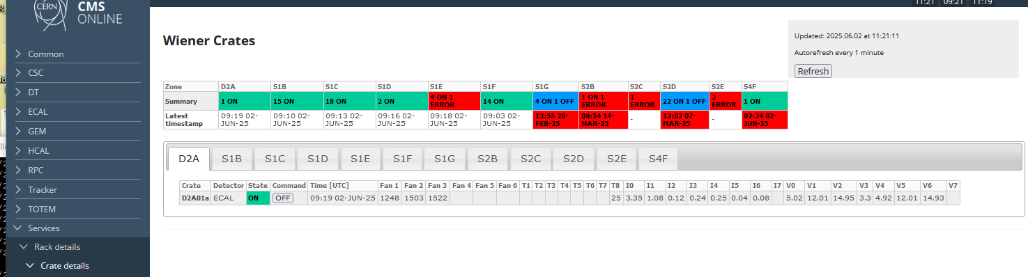

D2A crate

1. **PC: in case it is needed to** **switch On /OFF PC:**

In principle it is the duty of EAL DAQ (or central DAQ) On 1 June, it was done by ecal DAQ

Turning OFF PC: :

Command on

# cd ~ecaldev/utils/systools. *Only on cmsusr (putty) didn-t work need to log to*

*#ssh Bailleux@ecal-laser-room-05 for instance to act on PC02.*

# ./pc_reset ecal-laser-room-02

1. **Need to launch laser programm (for running DAQ ! ) => need remote connection**

No VNC remote control (1st June) . In principle it should be automatically launch

Jira ticket <https://its.cern.ch/jira/browse/CMSONS-16154>

What I did:

* Start Putty as usual,
* Login to PC with : # ssh bailleux@ecal-laser-room-02 -XY
* #cd /home
* # sudo x11vnc

It was OK once! And launch program was OK. I try to redo VNC connection another time, No succeed. And Problem No display XTERM, to launch laser program here on Putty directly instead of PC02 directly. As did before. Xwin32 was OK in the past.

See process on PC02: ps grep.. : X11VNC seems running ! but no way to start…

**Another method to start laser program:**

1. Open X-WIN32
2. New connection: MANUAL
3. Fill as it is here:
4. New XTERM windows opened.
5. Login :
6. Ssh bailleux@ecal-laser-room-02
7. Launch ./laser script OK in principle.

Program will run on another machine than PC02 so need later to stop and restart properly on PC02

1. **Start Laser script:**

/laser/monitor/dp3n # ./laser

Got error: the scope DS0 and the attenuators:

* SCOPE DSO: I have bypassed them on laser_h.cfg putting a * in front of the 3 lines HPxxxx. to avoid error starting laser program. But doesn’t matter if not OK.

Reboot SCOPE with PDU : (if needed, can try. not mandatory to get scope running)

# cd /nfshome0/daqoncall/DAQTools/pdu

# ./PDU_OFF pdu-sd01-6 then # ./PDU_ON pdu-sd01-6

6 is for port#6 which is the first scope. Scope are on port 6-7-8

1. **Once the safety as been enable with safety box ICS9 we can configure lasers:**

**For Blue laser DP2 :**

* Change current from 35A to 0 A . Acknowledge should be OK
* Put internal Shutter in OFF position. ON/OFF should work.
* Switch ON LDD then Q-switch -- Can failed, no way to come in P5 …
* Increase current to 35A.
* Reset the SHOT102 attenuator and put back legacy value (35%)
* Put internal trigger to see pulse on scope

**For green laser:**

* Change current A from 3.5A to 0A
* Put LDD ON it should be ON on the main GUI display even if it’s stay OFF on setting GUI
* Put current A=3.5A
* OPEN Shutter
* Reset the SHOT102 attenuator and put back legacy value (50%)
* Put internal trigger to see pulse on scope

**Reset the SHOT102 attenuator “HOME” button

Restart script with ./laser or ./run to get logfile.