**Personal notes during the visit at Photonics**

**26-29 March 2013**



**Bailleux David**



**26 March**

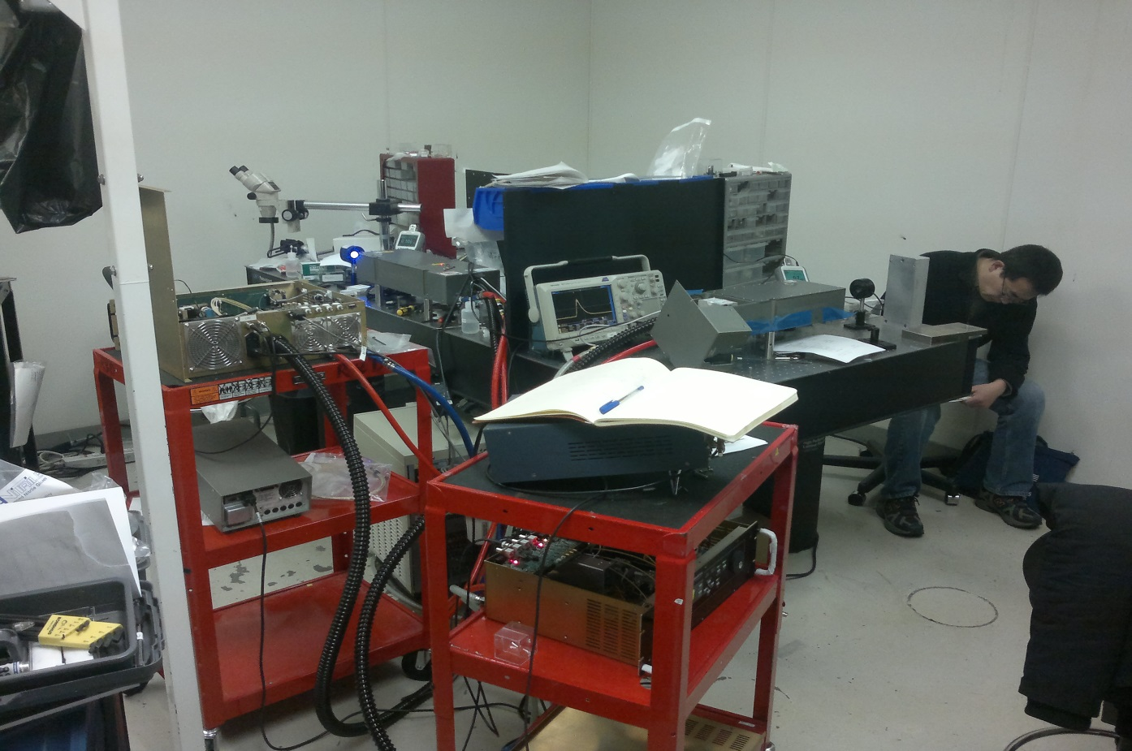

Laser1

Laser2

Chiller for both

Lab at Photonics.

1. **Info on the 1st laser DP2, ‘laser1’:**

The crystal THG has a damage. 3rd harmonic crystal. Not yet repaired.

1. **2nd laser DP2-447nm:**

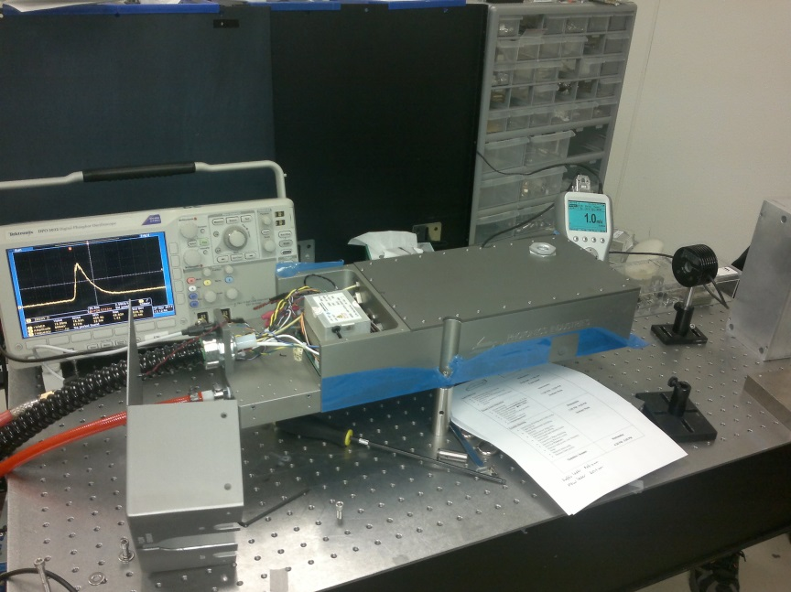

P= 108mW@39A, FWHM=19.8ns.

Graham say that 40A correspond to 65A of the laser1 because of calibration (module,ect)

Simmer function not yet installed-enable as laser1. This chip stabilizes the pulse width.

At 10Hz pulse width vary from 21.4-20.9ns.

39 A is the maximum !..

Laser2 setting:

P= 108mW@39A, FWHM=19.8ns.

Ta chiller = 30d Tdiode=27d

Ts (SHG)=49.9d Ta(SHG)=50d

Ts(THG)= 48 d Ta(THG)=48.2d

Blue threshold= 8.5A

1. Installation of the simmer function (chip)

100Hz: 20ns

10Hz: 20.7ns

1 Hz: 20.5ns

Measurement with the Caltech DSO, Agilent , at 35 A

100Hz: 20.1ns

50Hz : 20.1ns

20Hz : 20.8ns

10Hz: 20.9ns

1 Hz: 20.3ns

200Hz is the maximum due to diode .

1. **Diode power measurement** to understand the power different with laser1 (current different):

Diode 1: 490mW@39A,

Diode 2: 494mW@40A

It is consistent with laser1 diode but laser1 give same output power for 65A , not 40 !

To change the current limitation on the control display:

Select I=39A, go down next page. Press “cancel+enter” and then it is possible to go select- underline Imax=39A with the cursor.

**27 March**

For the new laser2: temperature of the chiller (one big chiller at photonics) is 29degrees. Graham said because of different diode than laser1. New type. Diode λ + or – 1 nm is enough to change the power.

At cern laser1 is 25degrees. If we change 1 diode, need to re adjust Ta chiller to match the wavelength. THG and SHG temp. also to be adjusted.

Graham concludes that laser2 is well running at 39A and it is not a calibration issue. It is due to diode λ . but why power is much higher with lower diode power ?..

1. **For the spare DP2 at CERN:**

2 solutions:

. remove water completely. And keep the 220V power supply connected.

. Or leave water and turn on laser few minutes every ~3 days to circulate water. And also check laser output. Check SHG-THG temp.

Solution 2. Seems the best in case spare laser need to be used in urgent case. And to avoid surprise…

1. **First DP2-1 repaired (afternoon):**

106mW@65A

FWHM=18.6ns. ETM laser1 = 8000hrs (333days)

Ta chiller = 30 degrees, Tdiode=29.2degrees. At CERN Tdiode-32degrees.. !?

Graham said that diode temp 29 or 32 is not big difference not a problem.

(While in the same time he said temp of +-1degree of diode can change the λ..)

Diff. power efficiency with DP2-2 🡪 diode λ: 807nm new laser, 806nm first laser.

1. **Replacing diode.**

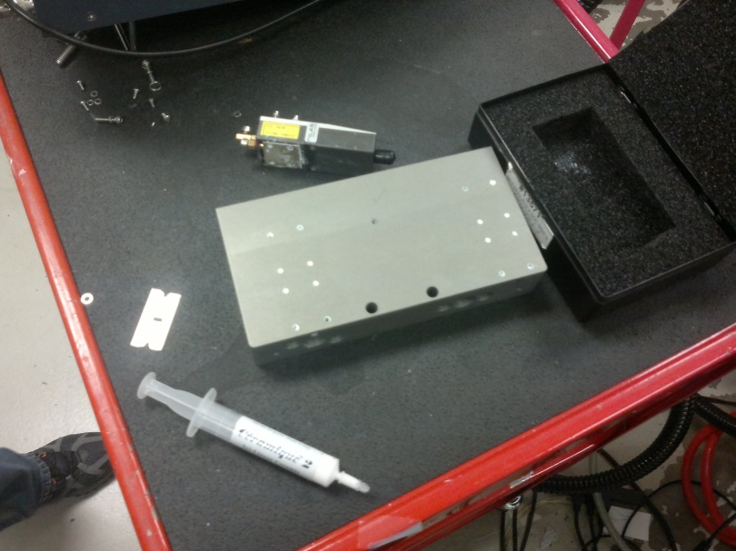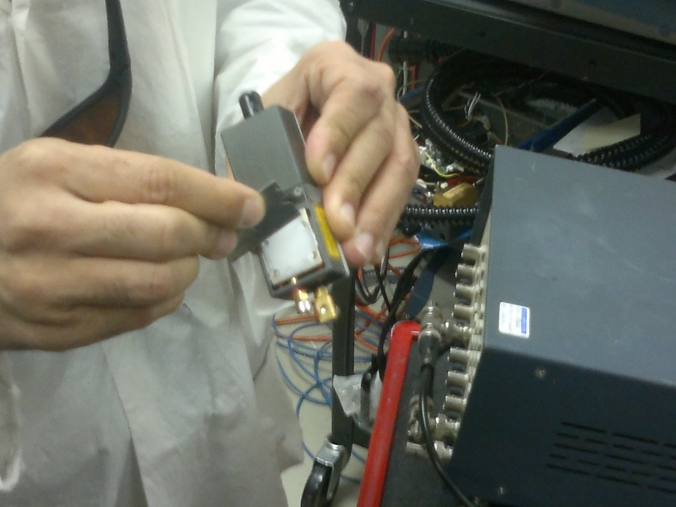

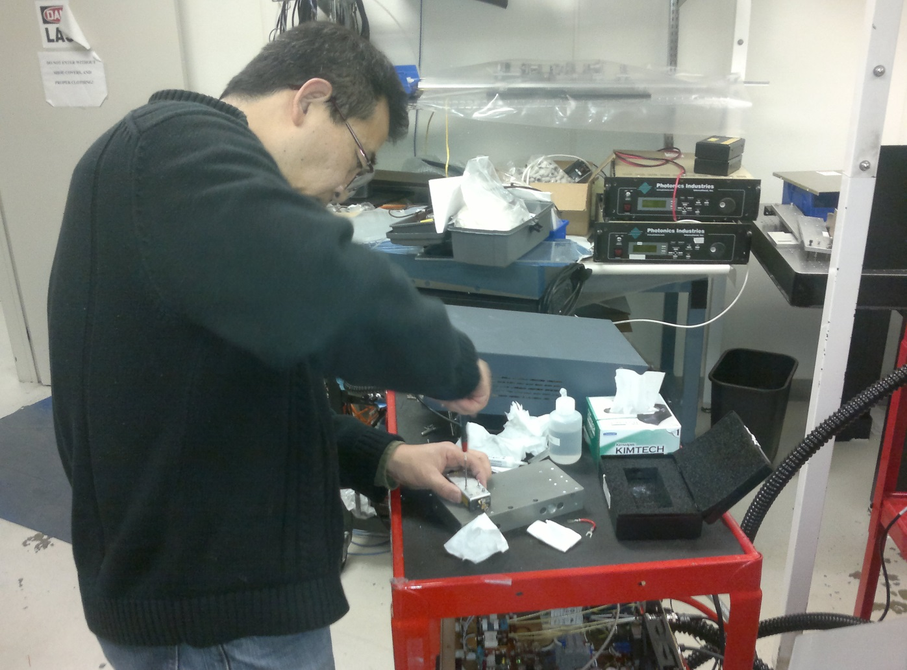

Pad Ceramic2. Thermal and electrical isolation

Cleaning with acetone

Remove the screw with the plastic insert and keep in order the washer, ect..

Keep always the bypass- electrical short circuit on new diode up to the full installation.

Check is no continuity between diode body and support plate.

Check fibre connector if any dust . else could burn the diode.

**Can’t measure the diode current on the cable (red&black)**

Diode ground are isolated from the driver LDD .

Using a scope could burnt it !

Easiest way:

On J102 connector there is test point “M” voltage pulsing 0-10V, 0-100A. to know the diode current.

Test point “X”: 5V (LDD enable)

Test point “L”: current set voltage from the controler

**Laser1 pulse width%frequency:**

At 67A:

100Hz: 20.1ns

50Hz: 20.2ns

20Hz: 20.1ns

10Hz: 20.1ns

1 Hz: 20.1ns

**Laser2 pulse width%frequency:**

At 35A:

100Hz: 19.1ns

50Hz: 19.2ns

10Hz: 19.2ns

New value – new measurement compare to 26March. Because laser2 was adjusted (end mirror) in order to stabilize FWHM.

**28 March**

**Laser cavity:** Only the end mirror is tunable. The one closest to the cable input.

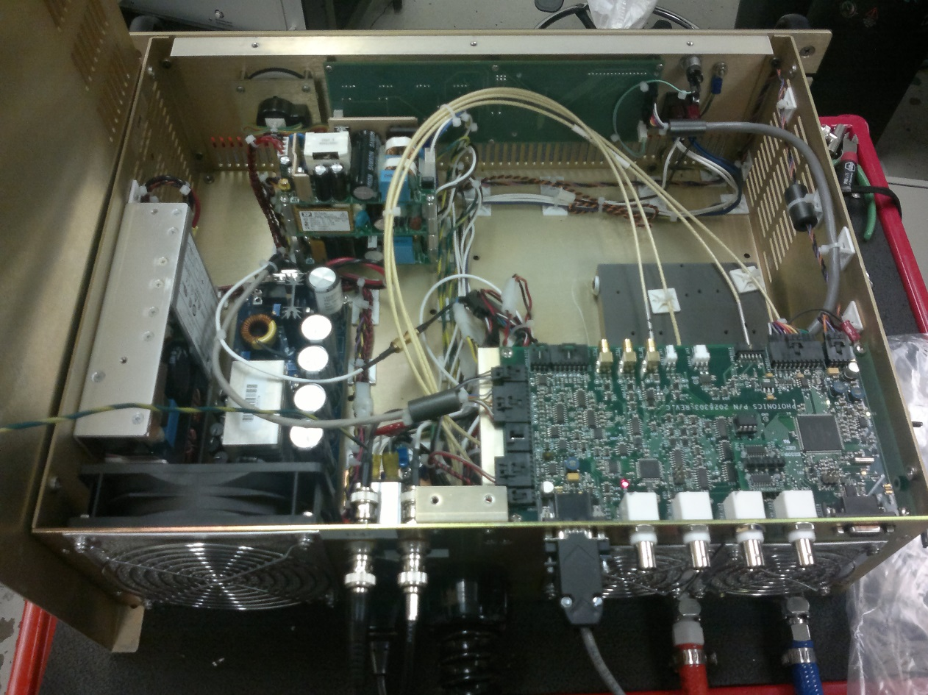

Overview of electrical part with Omar (engineer)

Diode driver

Diode power

power

Controlboard

boar

**Power supply:**

. Power supply for the driver diode: 250W

. 3 units in a tower:

Power supply for temperature control. The bottom one (shg-thg)

Power supply for 5-15V controller board

Power supply for pocko cell driver 15V, screen, main switch…

Color code:

. yellow&black: temperature controller

. orange&black: 5V control board

. purple&black: 15V control board

. red&black: 15V : switch voltage. Only ON with main laser button.

The others are continuously running with 220V socket.

When pluging 220V : 1 bip Ok , 3 bips BAD !

**Qswitch driver**

Inside the laser , there is a main HV driver supply, from quantum (same as TiS) for the pockel cell.

HV ~3.6kV

HV can be monitored: there is a free enrolled wire (green for laser2). Use powermeter between this wire and the ground (black cable on plastic connector, with orange and blue wire)

**Control board:**

This is the main board on control unit.

5-15V green LED ok

HB1 – HB2 red LED: flashing 1Hz ok . (HB – high bit)

Main button on front panel switch on: orange LED appears “CHILR”

Orange LED shutter when operating shutter. Light on = shutter open.

Closed to the shutter LED there is a fuse for the shutter. Can be bypass (with pince a epiler ex.) to be sure shutter is ok and not the problem.

Shutter is 5 V.

**Interface board**

Bellow the HV unit on laser.

2 indicators LED: flashing red ; communication ok

Connector with 3 pins is for communication.

Color code:

white&black: AC continusly running ,

white&blue: AC switch (only on with main laser button)

Diode: there is a temperature sensor for each diode. On the display, we only see 1 diode temp.

If any temp. is display 90degees -> max. resolution some short somewhere

If it’s too low -> not connected.

**Dawn board**

For SHG/THG

Board is thermal compound (ceramic if replaced..)

Before a full replacement : used a spare board ‘on fly’ for a short time (no cooling) to see if error disappeared

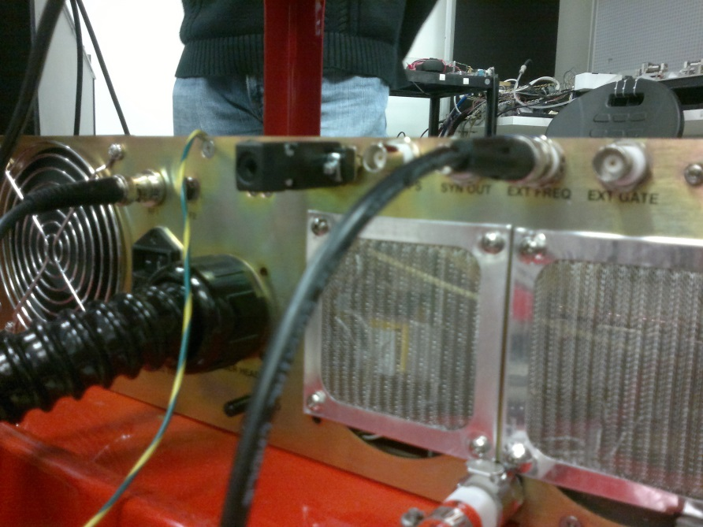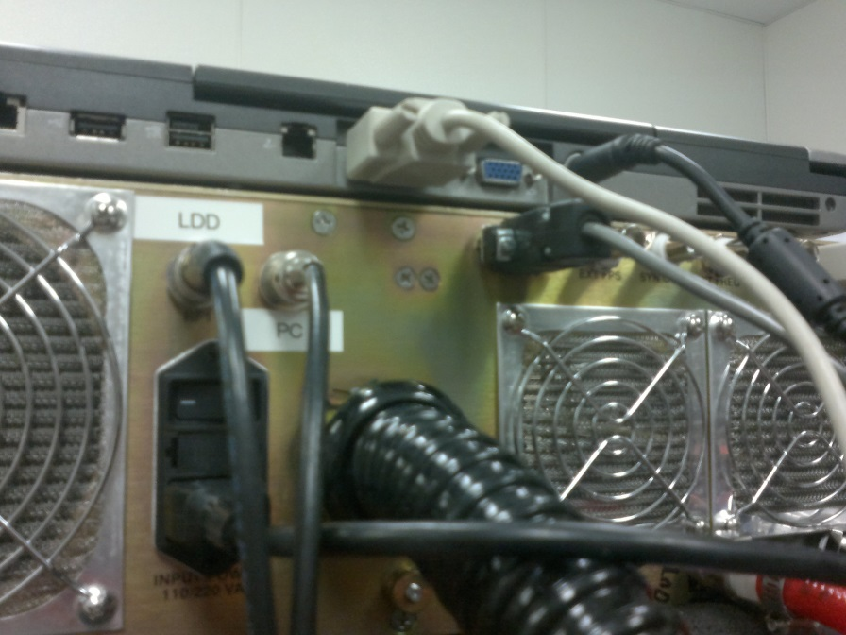More comment:

for the new laser, laser2, the external trigger is now on the control board directly . one of the 4 BNC output. On laser1 BNC connector was added to the back plane (inside cable goes directly to the laser head)

Laser2

Laser1